 

INSTITUTE OF ENGINEERING & RURAL TECHNOLOGY

26, Chaitham Lines, Jawahar Ganj,

New Rest House Railway Colony,

PrayagrAJ

***SESSION : 2023-2024***

**report FILE**

**NAME :** UJJAWAL MALVIYA

**BRANCH** : COMPUTER SCIENCE

& ENGINEERING

**ROLL NO.** : 2101100100061

**SUBJECT :**railways reservation system . (Report summited to: DR. A.P.J ABDUL KALAM TECHNICAL UNIVERSITY

FORMERLY UTTAR PRADESH TECHNICAL UNVERSITY,

LUCKNOW (UTTAR PRADESH) INDIA)

**SIGNATURE :**

**DECLARATION**

We,declare that the report entitled “RAILWAY RESERVATION SYSTEM” is based on our own work carried out during the course of my study. I assert that the statement made and conclusion drawn are an outcome of the project work.

We further declare that to the best of my knowledge and belief that the report does not contain any part of the word which has been submitted for the award of any other degree/diploma/certificate in this university/deemed university of India or any other country.

UJJAWAL MALVIYA

ROLL NO. 210110010061

ACKNOWLEDGEMENT

I would like to express my sincerest gratitude to all those who have supported, encouraged, and helped me in completing this project. It has been a long and arduous journey, and I am deeply grateful for the help and support of everyone mentioned below.

First and foremost, I would like to thank my project mentor “**Mr.Indubhusan Dubey”**sir & HOD of Department of Computer science **“Mr.Rohit Gupta”** sir, for their unwavering support and guidance throughout this project. Their expertise and keen eye have been invaluable in helping me to put together an impressive and comprehensive project. I am also thankful for their ongoing advice and feedback, which were essential in the completion of this project.

Ujjawal Malviya

Roll No.:- 2101100100061

CSE Department

IERT ,Prayagraj

INRODUCTION

HTML: HTML is the standard markup language for creating Web pages.

What is HTML?

* HTML stands for Hyper Text Markup Language
* HTML is the standard markup language for creating Web pages
* HTML describes the structure of a Web page
* HTML consists of a series of elements
* HTML elements tell the browser how to display the content
* HTML elements label pieces of content such as "this is a heading", "this is a paragraph", "this is a link", etc.



HTML is a markup language used by the browser to manipulate text, images, and other content, in order to display it in the required format. HTML was created by Tim Berners-Lee in 1991. The first-ever version of HTML was HTML 1.0, but the first standard version was HTML 2.0, published in 1995.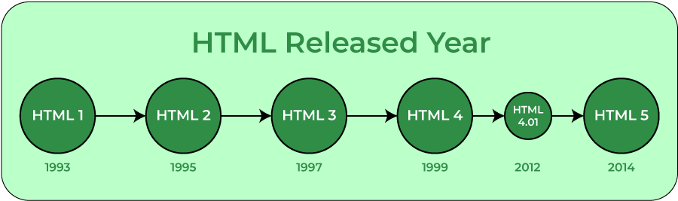

**<!DOCTYPE>:** It defines the document type or it instruct the browser about the version of HTML.

**<html >** :This tag informs the browser that it is an HTML document. Text between html tag describes the web document. It is a container for all other elements of HTML except <!DOCTYPE>

**<head>:** It should be the first element inside the <html> element, which contains the metadata(information about the document). It must be closed before the body tag opens.

**<title>:** As its name suggested, it is used to add title of that HTML page which appears at the top of the browser window. It must be placed inside the head tag and should close immediately. (Optional)

**<body>**: Text between body tag describes the body content of the page that is visible to the end user. This tag contains the main content of the HTML document.

**<h1>** : Text between <h1> tag describes the first level heading of the webpage.

**<p>**: Text between <p> tag describes the paragraph of the webpage.

## Features of HTML

1) It is a very **easy and simple language**. It can be easily understood and modified.

2) It is very easy to make an **effective presentation** with HTML because it has a lot of formatting tags.

3) It is a **markup language**, so it provides a flexible way to design web pages along with the text.

CSS(cascading style sheets):

**C**ascading **S**tyle **S**heets, fondly referred to as **CSS**, is a simply designed language intended to simplify the process of making web pages presentable. CSS allows you to apply styles to web pages. More importantly, CSS enables you to do this independently of the HTML that makes up each web page. It describes how a webpage should look: it prescribes colours, fonts, spacing, and much more. In short, you can make your website look however you want. CSS lets developers and designers define how it behaves, including how elements are positioned in the browser.

While HTML uses tags, CSS uses rulesets. CSS is easy to learn and understand, but it provides powerful control over the presentation of an HTML document.

**Why CSS?**

* **CSS saves time:**You can write CSS once and reuse the same sheet in multiple HTML pages.



* **Easy Maintenance:**To make a global change simply change the style, and all elements in all the webpages will be updated automatically.
* **Search Engines:**CSS is considered a clean coding technique, which means search engines won’t have to struggle to “read” its content.
* **Superior styles to HTML:**CSS has a much wider array of attributes than HTML, so you can give a far better look to your HTML page in comparison to HTML attributes.
* **Offline Browsing:**CSS can store web applications locally with the help of an offline cache. Using this we can view offline websites.

**CSS versions release years:**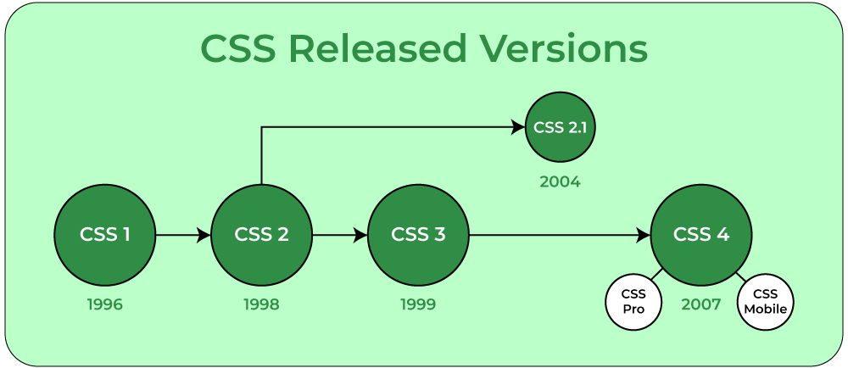

**CSS Syntax:**

CSS comprises style rules that are interpreted by the browser and then applied to the corresponding elements in your document. A style rule set consists of a selector and declaration block.

1. **Selector:** A selector in CSS is used to target and select specific HTML elements to apply styles to.
2. **Declaration:**A declaration in CSS is a combination of a property and its corresponding value.

Selector -- h1  
Declaration -- {color:blue;font size:12px;}

* The selector points to the HTML element you want to style.
* The declaration block contains one or more declarations separated by semicolons.
* Each declaration includes a CSS property name and a value, separated by a colon.

PHP(HYPERTEXT PREPROCESSOR):

What is PHP?

* PHP is an acronym for "PHP: Hypertext Preprocessor"
* PHP is a widely-used, open source scripting language
* PHP scripts are executed on the server
* PHP is free to download and use

**PHP is an amazing and popular language!**

It is powerful enough to be at the core of the biggest blogging system on the web (WordPress)!  
It is deep enough to run large social networks!  
It is also easy enough to be a beginner's first server side language!

## What is a PHP File?

* PHP files can contain text, HTML, CSS, JavaScript, and PHP code
* PHP code is executed on the server, and the result is returned to the browser as plain HTML
* PHP files have extension ".php"



What Can PHP Do?

* PHP can generate dynamic page content
* PHP can create, open, read, write, delete, and close files on the server
* PHP can collect form data
* PHP can send and receive cookies
* PHP can add, delete, modify data in your database
* PHP can be used to control user-access
* PHP can encrypt data

With PHP you are not limited to output HTML. You can output images or PDF files. You can also output any text, such as XHTML and XML.

Why PHP?

* PHP runs on various platforms (Windows, Linux, Unix, Mac OS X, etc.)
* PHP is compatible with almost all servers used today (Apache, IIS, etc.)
* PHP supports a wide range of databases
* PHP is free. Download it from the official PHP resource: [www.php.net](http://www.php.net/)
* PHP is easy to learn and runs efficiently on the server side

**DBMS(database management system):**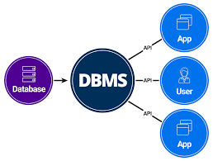

A Database Management System (DBMS) is a software system that is designed to manage and organize data in a structured manner. It allows users to create, modify, and query a database, as well as manage the security and access controls for that database.

**Key Features of DBMS**

* **Data modeling:** A DBMS provides tools for creating and modifying data models, which define the structure and relationships of the data in a database.
* **Data storage and retrieval:**A DBMS is responsible for storing and retrieving data from the database, and can provide various methods for searching and querying the data.
* **Concurrency control:** A DBMS provides mechanisms for controlling concurrent access to the database, to ensure that multiple users can access the data without conflicting with each other.
* **Data integrity and security:** A DBMS provides tools for enforcing data integrity and security constraints, such as constraints on the values of data and access controls that restrict who can access the data.
* **Backup and recovery:** A DBMS provides mechanisms for backing up and recovering the data in the event of a system failure.
* **DBMS can be classified into two types:** Relational Database Management System (RDBMS) and Non-Relational Database Management System (NoSQL or Non-SQL)
* **RDBMS:**Data is organized in the form of tables and each table has a set of rows and columns. The data are related to each other through primary and foreign keys.
* **NoSQL:**Data is organized in the form of key-value pairs, documents, graphs, or column-based. These are designed to handle large-scale, high-performance scenarios.

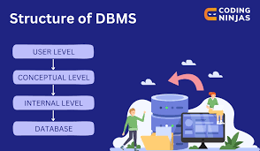

**DDL** is the short name for Data Definition Language, which deals with database schemas and descriptions, of how the data should reside in the database.

* **CREATE:** to create a database and its objects like (table, index, views, store procedure, function, and triggers)
* **ALTER:**alters the structure of the existing database
* **DROP:** delete objects from the database
* **TRUNCATE:** remove all records from a table, including all spaces allocated for the records are removed
* **COMMENT:**add comments to the data dictionary
* **RENAME:** rename an object

**DML** is the short name for Data Manipulation Language which deals with data manipulation and includes most common SQL statements such SELECT, INSERT, UPDATE, DELETE, etc., and it is used to store, modify, retrieve, delete and update data in a database.

* **SELECT:**retrieve data from a database
* **INSERT:** insert data into a table
* **UPDATE:** updates existing data within a table
* **DELETE:**Delete all records from a database table
* **MERGE:** UPSERT operation (insert or update)
* **CALL:**call a PL/SQL or Java subprogram
* **EXPLAIN PLAN:** interpretation of the data access path
* **LOCK TABLE:**concurrency Control

|  |  |
| --- | --- |
| ENTITIES | ATTRIBUTES |
| ->REGISTER    ->ADD TRAIN    ->ADD ROUTE  ->BOOKING | Firstname  Last name  Username  Email  Date of birth  Gender  Mobile number  Password  Trainname  Train number  Source  Destination  Departure  Arrival  Distance  Total seat  Trainname  Route  Source  Destination  Distance  Fare  Firstname  Lastname  Email  Gender  Mobile  Date of birth  Address  Aadhar  Date of travel  Train name  Class  berth |

|  |
| --- |
| ER DIAGRAM (CONCEPTUAL MODEL): |

Register

cancel

User

admin

Frontend(archeitecture):

Index.php:

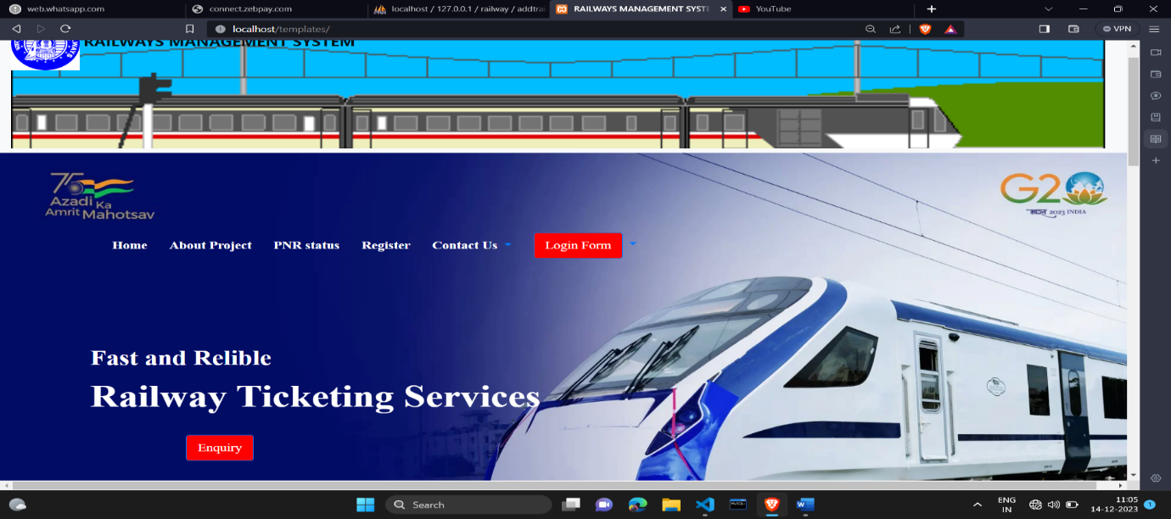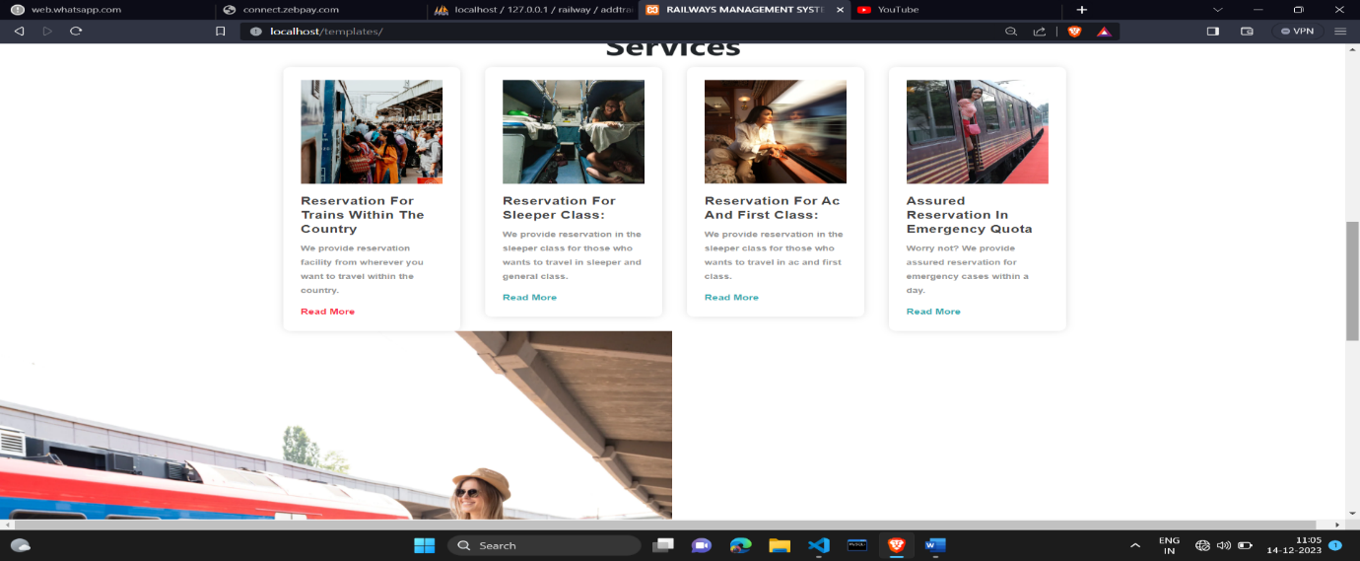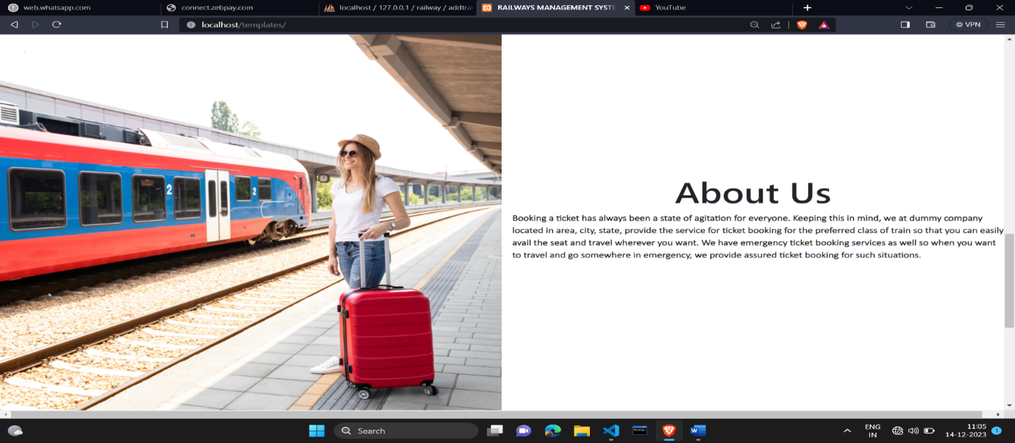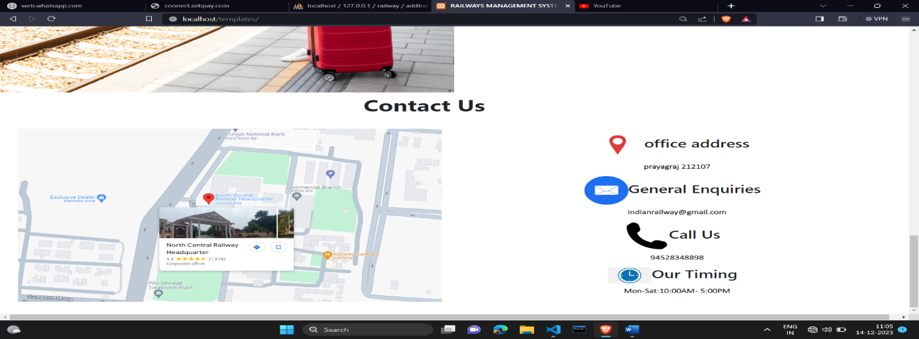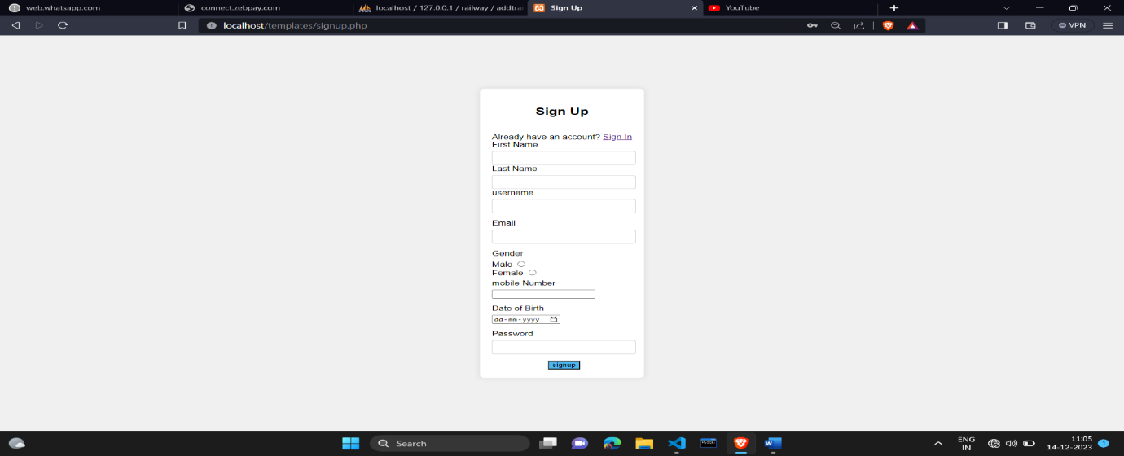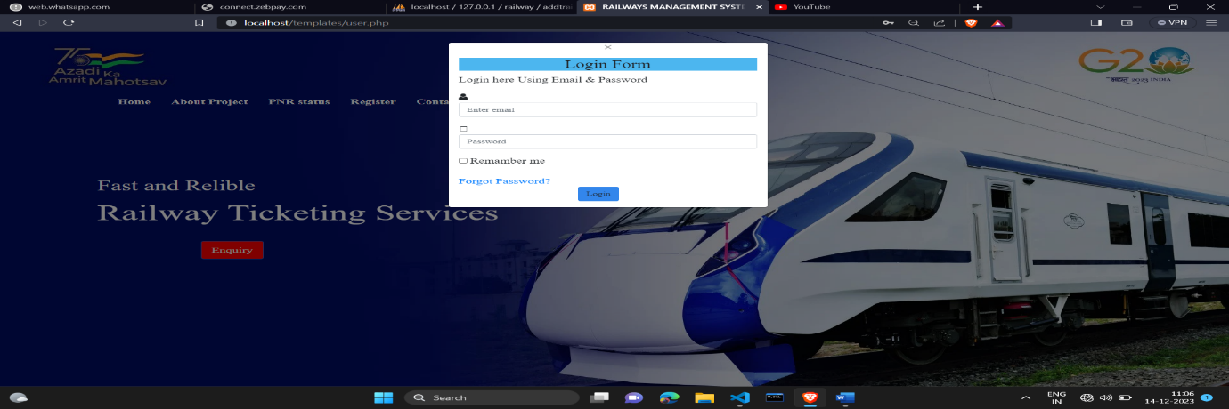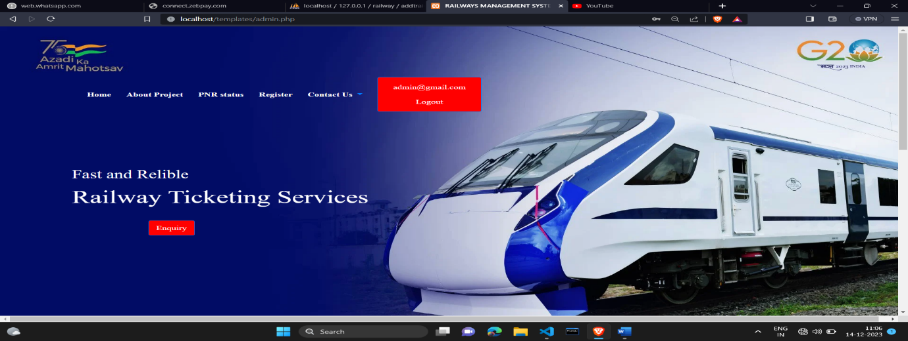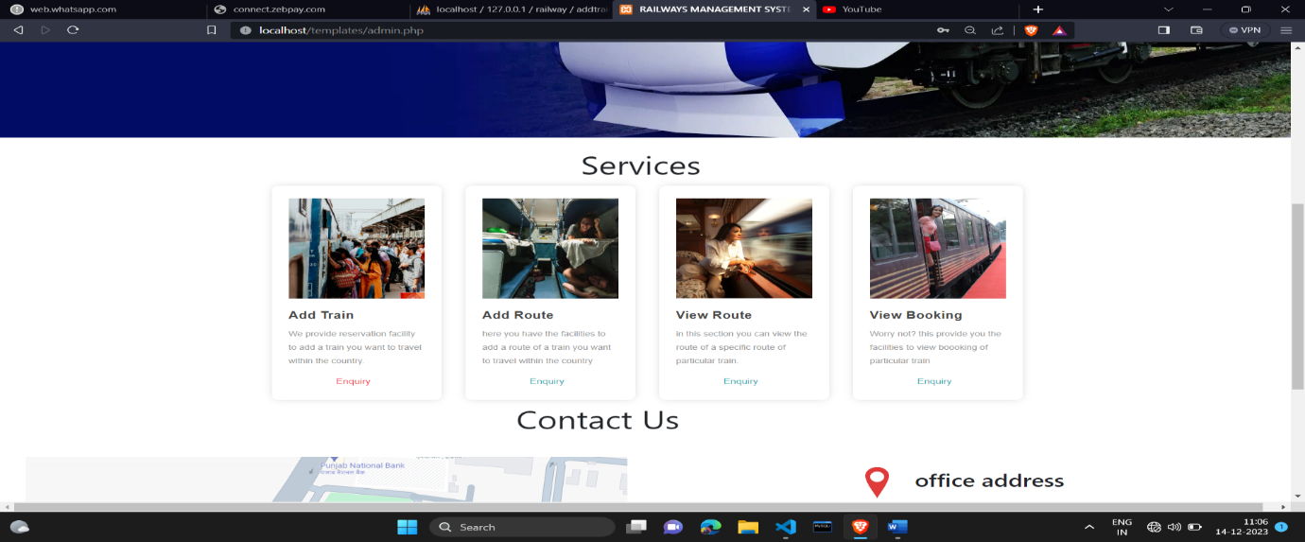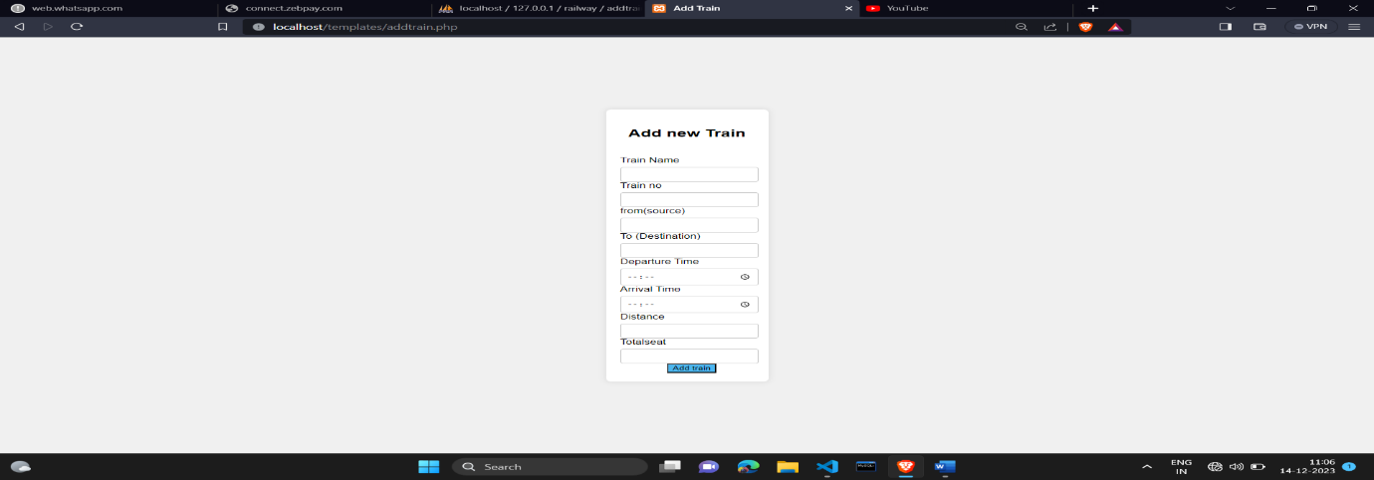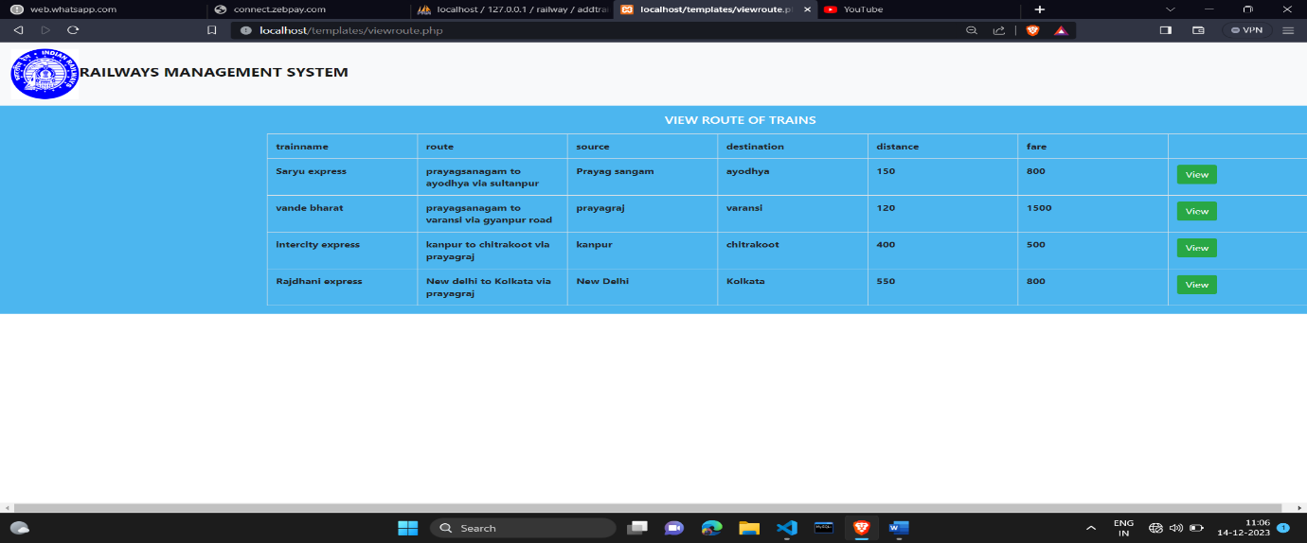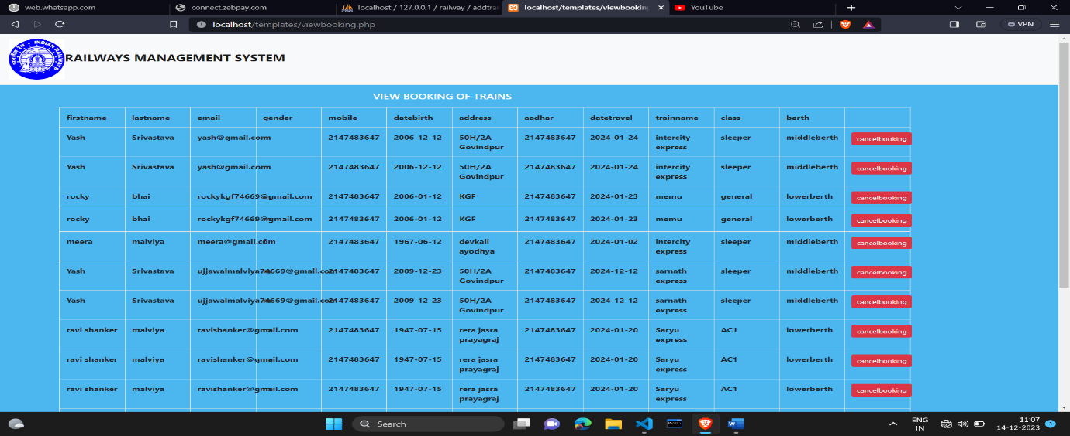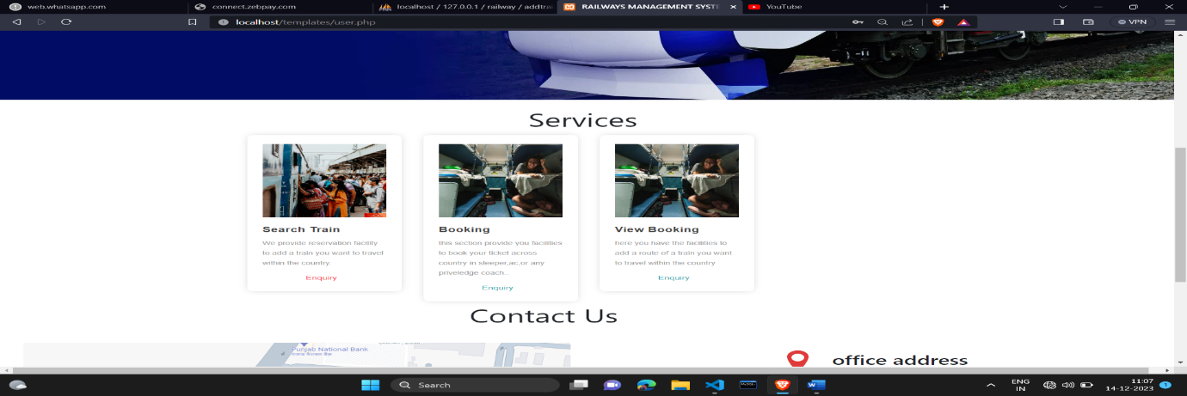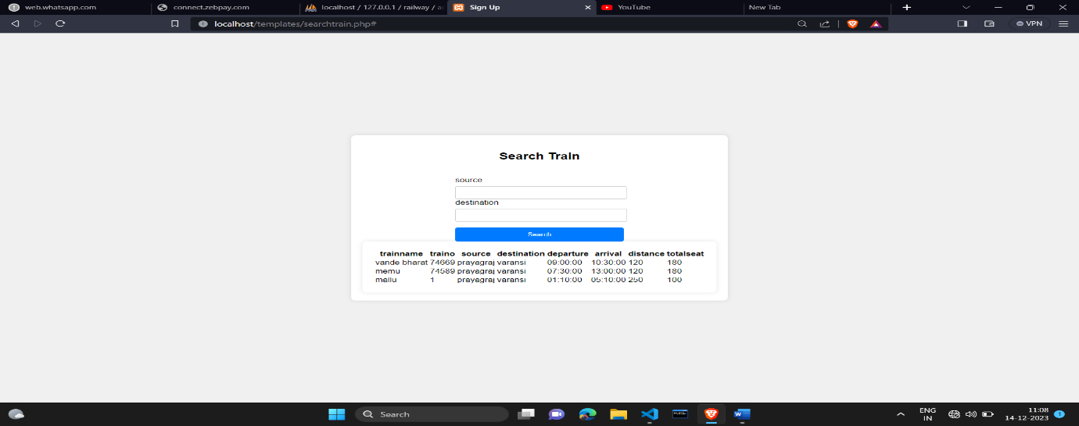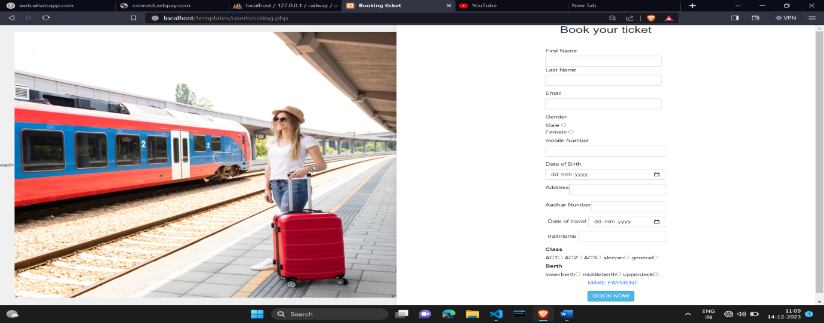

PROGRAM CODE:

Index.php:

<?php

session_start();

?>

<!doctype html>

<html lang="en">

<head>

  <title>RAILWAYS MANAGEMENT SYSTEM</title>

</head>

<body>

  <?php

  include ("connect.php");

  ?>

  <a>

    <nav class="navbar navbar-expand-lg navbar-light bg-light">

      <a class="navbar-brand" href="#"

        style=" width:150vw;height:30vh;background: url(train.gif);background-size: cover;"><img src="logo.png"

          height=100px width=100px alt="logo" background im><b>

          <font size="5px">RAILWAYS MANAGEMENT SYSTEM</font></a>

    </nav>

    <div class="box" style=" width: 100vw;height: 100vh;background: url(vande.webp);background-size: cover;">

      <nav class="navbar navbar-expand-lg">

        <li class="nav active">

          <a class="nav-link" href="index.php">

            <font color="white"><b>Home</b></font> <span class="sr-only">(current)</span>

          </a>

        </li>

        <li class="nav active">

          <a class="nav-link" href="#">

            <font color="white"><b>About Project</b></font> <span class="sr-only">(current)</span>

          </a>

        </li>

        <li class="nav active">

          <a class="nav-link" href="#">

            <font color="white"><b>PNR status</b></font> <span class="sr-only">(current)</span>

          </a>

        </li>

        <li class="nav active">

          <a class="nav-link" href="signup.php">

            <font color="white"><b>Register</b></font> <span class="sr-only">(current)</span>

          </a>

        </li>

        <li class="nav dropdown">

          <a class="nav-link dropdown-toggle" href="#" role="button" data-toggle="dropdown" aria-expanded="false">

            <font color="white"><b>

                Contact Us

            </font></b>

          </a>

          <div class="dropdown-menu">

            <a class="dropdown-item" href="india.html">=> Ministry of

              railways,Mumbai<br>phone:9566599956999<br>gmail:indianrailway@gmail.com</a>

            <a class="dropdown-item" href="india.html">=> NORTH central

              railways<br>phone:7877554455455<br>gmail:northrailway@gmail.com</a>

            <a class="dropdown-item" href="india.html">=> South

              railways<br>phone:9595697799<br>gmail:southrailway@gmail.com</a>

            <div class="dropdown-divider"></div>

          </div>

        </li>

        <li class="nav dropdown">

          <a class="nav-link dropdown-toggle" href="#" role="button" data-toggle="dropdown" aria-expanded="false">

            <font color="white"><b>

                <button type="button" class="btn btn-primary btn-lg show-modal" data-toggle="modal"

                  data-target="#myModal" style="margin-left:0%; margin-top:0%;background-color: red;">

                  Login Form

                </button>

            </font></b>

          </a>

          <div class="dropdown-menu">

            <a class="dropdown-item" href="admin.php">Admin Login</a>

            <a class="dropdown-item" href="user.php">User Login</a>

            <div class="dropdown-divider"></div>

          </div>

        </li>

      </nav>

      <div class="2" style="font-size: 190%; font-family:Gilroy;padding-top: 10%;"><font color="white">Fast and Relible</font><br><div class="1" style="font-size: 150%; font-family:Roboto; text-align: left;"><font color="white">Railway Ticketing Services</font></div></div>

        <button type="button" class="btn btn-primary btn-lg show-modal" style="margin:2%;background-color: red;margin-left: 10%;">Enquiry </button>

      </div>

<div>

   <div<h4 style="margin:45%;margin-top:10%;font-size: 50px;">Services</h4></div>

   <div class="container">

    <div class="row">

        <div class="col-md-3 col-sm-6">

            <div class="serviceBox">

                <div class="service-icon" style="background-image: url(country.webp);background-size: cover;">

                    <span><i class="fa fa-railway"></i></span>

                </div>

                <h3 class="title">Reservation for trains within the country</h3>

                <p class="description">We provide reservation facility from wherever you want to travel within the country.</p>

                <a href="#" class="read-more">Read More</a>

            </div>

        </div>

        <div class="col-md-3 col-sm-6">

            <div class="serviceBox cyan">

                <div class="service-icon" style="background-image: url(sleeper.webp);background-size: cover;">

                    <span><i class="fa fa-railway"></i></span>

                </div>

                <h3 class="title">Reservation for sleeper class:</h3>

                <p class="description">We provide reservation in the sleeper class for those who wants to travel in sleeper and general class.</p>

                <a href="#" class="read-more">Read More</a>

            </div>

        </div>

        <div class="col-md-3 col-sm-6">

            <div class="serviceBox cyan">

                <div class="service-icon" style="background-image: url(ac.webp);background-size: cover;">

                    <span><i class="fa fa-railway"></i></span>

                </div>

                <h3 class="title">Reservation for ac and first class:</h3>

                <p class="description">We provide reservation in the sleeper class for those who wants to travel in ac and first class.</p>

                <a href="#" class="read-more">Read More</a>

            </div>

        </div>

        <div class="col-md-3 col-sm-6">

            <div class="serviceBox cyan">

                <div class="service-icon" style="background-image: url(quota.webp);background-size: cover;">

                    <span><i class="fa fa-railway"></i></span>

                </div>

                <h3 class="title">Assured reservation in emergency quota</h3>

                <p class="description">Worry not? We provide assured reservation for emergency cases within a day.</p>

                <a href="#" class="read-more">Read More</a>

            </div>

        </div>

    </div>

</div>

    </div>

  </div>

    <div class="con">

      <div class="image">

        <img src="station.webp">

      </div>

      <div class="text">

        <h1 style="text-align:center; font-size: 70px;">About Us</h1>

        <p style="font-size:20px; font-family:Calibri Light;margin-left: 2%;">Booking a ticket has always been a state

          of agitation for everyone.

          Keeping this in mind, we at dummy company located in area, city, state, provide the service

          for ticket booking for the preferred class of train so that you can easily avail the seat and

          travel wherever you want. We have emergency ticket booking services as well so when you want to

          travel and go somewhere in emergency, we provide assured ticket booking for such situations.</p>

      </div>

    </div>

    <div>

      <div<h4 style="margin:40%;margin-top:10%;font-size: 50px;">Contact Us</h4>

    </div>

    <div class="con" style="margin:2%;">

      <div class="image">

        <img src="raail map.png">

      </div>

      <div class="text">

        <h1 style="text-align:center; font-size:35px;"><img src="location.jpg" style="height: 10%;width: 10%;"> office

          address</h1>

        <p style="font-size:20px; font-family:Calibri Light;margin-left: 2%;text-align: center;">prayagraj 212107</p>

        <h1 style="text-align:center; font-size:35px;"><img src="massage.png" style="height: 10%;width: 10%;">General

          Enquiries</h1>

        <p style="font-size:20px; font-family:Calibri Light;margin-left: 2%;text-align: center;">indianrailway@gmail.com

        </p>

        <h1 style="text-align:center; font-size:35px;"><img src="call.png" style="height: 10%;width: 10%;">Call Us</h1>

        <p style="font-size:20px; font-family:Calibri Light;margin-left: 2%;text-align: center;">94528348898</p>

        <h1 style="text-align:center; font-size:35px;"><img src="time.png" style="height: 10%;width: 10%;">Our Timing

        </h1>

        <p style="font-size:20px; font-family:Calibri Light;margin-left: 2%;text-align: center;">Mon-Sat:10:00AM -

          5:00PM</p>

      </div>

    </div>

    </div>

    <!-- Optional JavaScript; choose one of the two! -->

    <!-- Option 1: jQuery and Bootstrap Bundle (includes Popper) -->

    <script src="https://cdn.jsdelivr.net/npm/jquery@3.5.1/dist/jquery.slim.min.js"

      integrity="sha384-DfXdz2htPH0lsSSs5nCTpuj/zy4C+OGpamoFVy38MVBnE+IbbVYUew+OrCXaRkfj"

      crossorigin="anonymous"></script>

    <script src="https://cdn.jsdelivr.net/npm/bootstrap@4.6.2/dist/js/bootstrap.bundle.min.js"

      integrity="sha384-Fy6S3B9q64WdZWQUiU+q4/2Lc9npb8tCaSX9FK7E8HnRr0Jz8D6OP9dO5Vg3Q9ct"

      crossorigin="anonymous"></script>

</body>

</html>

Connect.php:

<?php

$host="localhost";

$root="root";

$password="";

$dbname="railway";

$connect=mysqli_connect($host,$root,$password,$dbname);

?>

Register.php:

<?php

session_start();

?>

<!DOCTYPE html>

<html lang="en">

<head>

  <meta charset="UTF-8">

  <title>Sign Up</title>

  <link rel="stylesheet" href="styles.css">

</head>

<body>

<?php

  include("connect.php");

  ?>

  <div class="container">

  <?php

      if (isset($_POST['submit'])) {

        $firstname=$_POST['firstname'];

        $lastname=$_POST['lastname'];

        $username=$_POST['username'];

        $email=$_POST['email'];

        $gender=$_POST['gender'];

        $mobile=$_POST['mobile'];

        $datebirth=$_POST['datebirth'];

        $password=$_POST['password'];

        $error=array();

        if (empty($firstname)) {

            $error['p']="Enter First name";

        }elseif (empty($lastname)) {

            $error['p']="Enter Last Name";

        }elseif (empty($username)) {

            $error['p']="Enter user name";

        }

        elseif (empty($email)) {

            $error['p']="Enter Email";

        }

        elseif (empty($gender)) {

            $error['p']="Enter Gender";

        }

        elseif (empty($mobile)) {

            $error['p']="Enter Mobile";

        }

        elseif (empty($datebirth)) {

            $error['p']="Enter date of birth";

        }

        elseif (empty($password)) {

            $error['p']="Enter password";

        }

        else {

            $query="INSERT INTO register(firstname,lastname,username,email,gender,mobile,datebirth,password) VALUES( '$firstname', '$lastname','$username','$email','$gender','$mobile','$datebirth','$password')";

            $result=mysqli_query($connect,$query);

            if ($result) {

               echo "<script>alert('Registration successfull !')</script>";

            }

        }

    }

    if(isset($error['p'])){

        $er=$error['p'];

        $show="<h5 class='alert alert-danger'>$er</h5>";

    }

    else{

        $show="";

    }

      ?>

    <form action="" method="post" enctype="multipart/form_data">

      <?php

      echo $show;

      ?>

      <h2>Sign Up</h2><br>

      <span>Already have an account? <a href="index.php">Sign In</a></span>

      <div class="form-group">

        <label for="username">First Name</label>

        <input class="form-control"type="text" id="username" name="firstname" required>

        <label for="username">Last Name</label>

        <input class="form-control" type="text" id="username" name="lastname" required>

        <label for="username">username</label>

        <input class="form-control"type="text" id="username" name="username" required>

      </div>

      <div class="form-group">

        <label for="email">Email</label>

        <input class="form-control"type="email" id="email" name="email" required>

      </div>

      <div class="choices">

        <label for="Gender">Gender</label>

        <div>

        <label for="choices">Male <input type="radio"  name="gender" value="m">

        <label for="choices">Female <input type="radio"  name="gender" value="f">

      </div>

    </div>

    <div class="form-group">

      <label for="number">mobile Number</label>

      <input class="form-control"type="number" name="mobile" required>

    </div>

    <div class="form-group">

      <label for="date">Date of Birth</label>

      <input class="form-control"type="date" name="datebirth" required>

    </div>

      <div class="form-group">

        <label for="password">Password</label>

        <input class="form-control"type="password" id="password" name="password" required>

      </div>

      <div style="margin-left: 40%;">

      <a href="index.php" type="index.php"></a>

      <input style="background-color: rgb(76, 182, 239);"type="submit" value="signup" name="submit" class="btn btn-success my-3">

      </div>

    </form>

  </div>

</body>

</html>

LOGIN:

Admin.php:

<?php

session_start();

include("connect.php");

if (isset($_POST['login'])) {

    $email=$_POST['email'];

    $password=$_POST['password'];

    $error=array();

    $q="SELECT * FROM register WHERE email='$email' AND password='$password'";

    $qq=mysqli_query($connect,$q);

    $row=mysqli_fetch_array($qq);

    if(empty($email)){

        $error['login']="Enter email";

    }else if(empty($password)){

        $error['login']="Enter Password";

    }

    if(count($error)==0){

        $query="SELECT * FROM register WHERE email='$email' AND password='$password'";

        $res=mysqli_query($connect,$query);

        if(mysqli_num_rows($res)){

            echo "<script>alert('Done')</script>";

            $_SESSION['admin']=$email;

            header("Location:admin.php");

        }else{

            echo "<script>alert('Invalid Account')</script>";

        }

    }

}

if(isset($error['login'])){

$l=$error['login'];

$show="<h5 class='text-center alert alert-danger'>$l</h5>";

}

else{

    $show="";

}

?>

<!doctype html>

<html lang="en">

  <head>

    <title>RAILWAYS MANAGEMENT SYSTEM</title>

  </head>

  <body>

  <a>

      <div class="box" style=" width: 100vw;height: 100vh;background: url(vande.webp);background-size: cover;">

        <nav class="navbar navbar-expand-lg">

            <li class="nav active">

              <a class="nav-link" href="index.php"><font color="white"><b>Home</b></font> <span class="sr-only">(current)</span></a>

            </li>

            <li class="nav active">

              <a class="nav-link" href="#"><font color="white"><b>About Project</b></font> <span class="sr-only">(current)</span></a>

            </li>

            <li class="nav active">

              <a class="nav-link" href="#"><font color="white"><b>PNR status</b></font> <span class="sr-only">(current)</span></a>

            </li>

            <li class="nav active">

              <a class="nav-link" href="signup.php"><font color="white"><b>Register</b></font> <span class="sr-only">(current)</span></a>

            </li>

            <li class="nav dropdown">

                <a class="nav-link dropdown-toggle" href="#" role="button" data-toggle="dropdown" aria-expanded="false"><font color="white"><b>

                  Contact Us

                </font></b></a>

                <div class="dropdown-menu">

                  <a class="dropdown-item" href="#">=> Ministry of railways,Mumbai<br>phone:9566599956999<br>gmail:indianrailway@gmail.com</a>

                  <a class="dropdown-item" href="#">=> NORTH central railways<br>phone:7877554455455<br>gmail:northrailway@gmail.com</a>

                  <a class="dropdown-item" href="#">=> South railways<br>phone:9595697799<br>gmail:southrailway@gmail.com</a>

                  <div class="dropdown-divider"></div>

                </div>

            </li>

            <li class="nav active">

                <div class="container">

                  <div class="row">

                      <div class="col-md-12">

                          <div class="modal-box">

                              <!-- Button trigger modal -->

                              <button type="button" class="btn btn-primary btn-lg show-modal" data-toggle="modal" data-target="#myModal" style="background-color: red; ">

                              <?php

                                                    if(isset($_SESSION['admin'])){

                                                        $user=$_SESSION['admin'];

                                                        echo '

                                                        <li class="nav-item"><a class="nav-link text-white" href="#">'.$user.'</a></li>

                                                        <li class="nav-item"><a class="nav-link text-white" href="logout.php">Logout</a></li>

                                                        ';

                                                    }

                                                    else{

                                                        echo 'Login Form';

                                                    }

                                                    ?>

                              </button>

                              <!-- Modal -->

                                <div class="modal fade" id="myModal" tabindex="-1" role="dialog" aria-labelledby="myModalLabel">

                                    <div class="modal-dialog" role="document">

                                        <div class="modal-content clearfix">

                                            <button type="button" class="close" data-dismiss="modal" aria-label="Close"><span aria-hidden="true">×</span></button>

                                            <div class="modal-body">

                                                <h3 class="title" style="text-align: center; background-color: rgb(76, 182, 239)">Login Form</h3>

                                                <p class="description">Login here Using Email & Password</p>

                                                <?php

                                                echo $show;

                                                ?>

                                                <form action="" method="post">

                                                    <div class="form-group">

                                                        <span class="input-icon"><i class="fa fa-user"></i></span>

                                                        <input type="email" class="form-control" name="email" placeholder="Enter email">

                                                    </div>

                                                    <div class="form-group">

                                                        <span class="input-icon"><i class="fas fa-key"></i></span>

                                                        <input type="password" class="form-control" name="password" placeholder="Password">

                                                    </div>

                                                    <div class="form-group checkbox">

                                                        <input type="checkbox">

                                                        <label>Remamber me</label>

                                                    </div>

                                                    <a href="#" class="forgot-pass">Forgot Password?</a><br>

                                                   <div>

                                                    <a href="#" style="margin-left: 40%;">

                                                    <button class="btn" name="login" style="text-align: center; background-color: rgb(51, 134, 235);">Login</button>

                                                    <!-- <input type="submit" value="Login" name="login" class="btn btn-dark"> -->

                                                    </a>

                                                    </div>

                                                </form></div></div></div></div></div> </div></div></div>

          </li>

      </nav>

        <div class="2" style="font-size: 190%; font-family:Gilroy;padding-top: 10%;"><font color="white">Fast and Relible</font><br><div class="1" style="font-size: 150%; font-family:Roboto; text-align: left;"><font color="white">Railway Ticketing Services</font></div></div>

        <button type="button" class="btn btn-primary btn-lg show-modal" style="margin:2%;background-color: red;margin-left: 10%;">Enquiry </button>

      </div>

<div>

   <div<h4 style="margin:45%;margin-top:10%;font-size: 50px;">Services</h4></div>

   <div class="container">

    <div class="row">

        <div class="col-md-3 col-sm-6">

            <div class="serviceBox">

                <div class="service-icon" style="background-image: url(country.webp);background-size: cover;">

                    <span><i class="fa fa-railway"></i></span>

                </div>

                <h3 class="title">add train</h3>

                <p class="description">We provide reservation facility to add a train you want to travel within the country.</p>

                <a href="addtrain.php" class="read-more" style="margin-left:35%;">Enquiry</a>

            </div>

        </div>

        <div class="col-md-3 col-sm-6">

            <div class="serviceBox cyan">

                <div class="service-icon" style="background-image: url(sleeper.webp);background-size: cover;">

                    <span><i class="fa fa-railway"></i></span>

                </div>

                <h3 class="title">Add Route</h3>

                <p class="description">here you have the facilities to add a route of a train you want to travel within the country</p>

                <a href="addroute.php" class="read-more"style="margin-left:35%;">Enquiry</a>

            </div>

        </div>

        <div class="col-md-3 col-sm-6">

            <div class="serviceBox cyan">

                <div class="service-icon" style="background-image: url(ac.webp);background-size: cover;">

                    <span><i class="fa fa-railway"></i></span>

                </div>

                <h3 class="title">view route</h3>

                <p class="description">in this section you can view the route of a specific route of particular train.</p>

                <a href="viewroute.php" class="read-more"style="margin-left:35%;">Enquiry</a>

            </div>

        </div>

        <div class="col-md-3 col-sm-6">

            <div class="serviceBox cyan">

                <div class="service-icon" style="background-image: url(quota.webp);background-size: cover;">

                    <span><i class="fa fa-railway"></i></span>

                </div>

                <h3 class="title">view Booking</h3>

                <p class="description">Worry not? this provide you the facilities to view boooking of particular train</p>

                <a href="viewbooking.php" class="read-more"style="margin-left:35%;">Enquiry</a>

            </div></div></div></div></div></div>

<div>

    <div<h4 style="margin:40%;margin-top:10%;font-size: 50px;">Contact Us</h4></div>

  <div class="con" style="margin:2%;">

    <div class="image">

      <img src="raail map.png">

    </div>

    <div class="text">

      <h1 style="text-align:center; font-size:35px;"><img src="location.jpg" style="height: 10%;width: 10%;"> office address</h1>

      <p style="font-size:20px; font-family:Calibri Light;margin-left: 2%;text-align: center;">prayagraj 212107</p>

      <h1 style="text-align:center; font-size:35px;"><img src="massage.png" style="height: 10%;width: 10%;">General Enquiries</h1>

      <p style="font-size:20px; font-family:Calibri Light;margin-left: 2%;text-align: center;">indianrailway@gmail.com</p>

      <h1 style="text-align:center; font-size:35px;"><img src="call.png" style="height: 10%;width: 10%;">Call Us</h1>

      <p style="font-size:20px; font-family:Calibri Light;margin-left: 2%;text-align: center;">94528348898</p>

      <h1 style="text-align:center; font-size:35px;"><img src="time.png" style="height: 10%;width: 10%;">Our Timing</h1>

      <p style="font-size:20px; font-family:Calibri Light;margin-left: 2%;text-align: center;">Mon-Sat:10:00AM - 5:00PM</p>

    </div>

  </div>

</div>

    <script src="https://cdn.jsdelivr.net/npm/jquery@3.5.1/dist/jquery.slim.min.js" integrity="sha384-DfXdz2htPH0lsSSs5nCTpuj/zy4C+OGpamoFVy38MVBnE+IbbVYUew+OrCXaRkfj" crossorigin="anonymous"></script>

    <script src="https://cdn.jsdelivr.net/npm/bootstrap@4.6.2/dist/js/bootstrap.bundle.min.js" integrity="sha384-Fy6S3B9q64WdZWQUiU+q4/2Lc9npb8tCaSX9FK7E8HnRr0Jz8D6OP9dO5Vg3Q9ct" crossorigin="anonymous"></script>

  </body>

</html>

User.php:

<?php

session_start();

include("connect.php");

if (isset($_POST['login'])) {

    $email=$_POST['email'];

    $password=$_POST['password'];

    $error=array();

    $q="SELECT * FROM register WHERE email='$email' AND password='$password'";

    $qq=mysqli_query($connect,$q);

    $row=mysqli_fetch_array($qq);

    if(empty($email)){

        $error['login']="Enter email";

    }else if(empty($password)){

        $error['login']="Enter Password";

    }

    if(count($error)==0){

        $query="SELECT * FROM register WHERE email='$email' AND password='$password'";

        $res=mysqli_query($connect,$query);

        if(mysqli_num_rows($res)){

            echo "<script>alert('Done')</script>";

            $_SESSION['user']=$email;

            header("Location:user.php");

        }else{

            echo "<script>alert('Invalid Account')</script>";

        }

    }

}

if(isset($error['login'])){

$l=$error['login'];

$show="<h5 class='text-center alert alert-danger'>$l</h5>";

}

else{

    $show="";

}

?>

<!doctype html>

<html lang="en">

  <head>

    <title>RAILWAYS MANAGEMENT SYSTEM</title>

</head>

  <body>

  <a>

      <div class="box" style=" width: 100vw;height: 100vh;background: url(vande.webp);background-size: cover;">

        <nav class="navbar navbar-expand-lg">

            <li class="nav active">

              <a class="nav-link" href="index.php"><font color="white"><b>Home</b></font> <span class="sr-only">(current)</span></a>

            </li>

            <li class="nav active">

              <a class="nav-link" href="#"><font color="white"><b>About Project</b></font> <span class="sr-only">(current)</span></a>

            </li>

            <li class="nav active">

              <a class="nav-link" href="#"><font color="white"><b>PNR status</b></font> <span class="sr-only">(current)</span></a>

            </li>

            <li class="nav active">

              <a class="nav-link" href="signup.php"><font color="white"><b>Register</b></font> <span class="sr-only">(current)</span></a>

            </li>

            <li class="nav dropdown">

                <a class="nav-link dropdown-toggle" href="#" role="button" data-toggle="dropdown" aria-expanded="false"><font color="white"><b>

                  Contact Us

                </font></b></a>

                <div class="dropdown-menu">

                  <a class="dropdown-item" href="#">=> Ministry of railways,Mumbai<br>phone:9566599956999<br>gmail:indianrailway@gmail.com</a>

                  <a class="dropdown-item" href="#">=> NORTH central railways<br>phone:7877554455455<br>gmail:northrailway@gmail.com</a>

                  <a class="dropdown-item" href="#">=> South railways<br>phone:9595697799<br>gmail:southrailway@gmail.com</a>

                  <div class="dropdown-divider"></div>

                </div>

            </li>

            <li class="nav active">

                <div class="container">

                  <div class="row">

                      <div class="col-md-12">

                          <div class="modal-box">

                              <!-- Button trigger modal -->

                              <button type="button" class="btn btn-primary btn-lg show-modal" data-toggle="modal" data-target="#myModal" style="margin-left:0%; margin-top:0%;background-color: red;">

                              <?php

                                                    if(isset($_SESSION['user'])){

                                                        $user=$_SESSION['user'];

                                                        echo '

                                                        <li class="nav-item"><a class="nav-link text-white" href="#">'.$user.'</a></li>

                                                        <li class="nav-item"><a class="nav-link text-white" href="logout.php">Logout</a></li>

                                                        ';

                                                    }

                                                    else{

                                                        echo 'Login Form';

                                                    }

                                                    ?>

                              </button>

                              <!-- Modal -->

                                <div class="modal fade" id="myModal" tabindex="-1" role="dialog" aria-labelledby="myModalLabel">

                                    <div class="modal-dialog" role="document">

                                        <div class="modal-content clearfix">

                                            <button type="button" class="close" data-dismiss="modal" aria-label="Close"><span aria-hidden="true">×</span></button>

                                            <div class="modal-body">

                                                <h3 class="title" style="text-align: center; background-color: rgb(76, 182, 239)">Login Form</h3>

                                                <p class="description">Login here Using Email & Password</p>

                                                <?php

                                                echo $show;

                                                ?>

                                                <form action="" method="post">

                                                    <div class="form-group">

                                                        <span class="input-icon"><i class="fa fa-user"></i></span>

                                                        <input type="email" class="form-control" name="email" placeholder="Enter email">

                                                    </div>

                                                    <div class="form-group">

                                                        <span class="input-icon"><i class="fas fa-key"></i></span>

                                                        <input type="password" class="form-control" name="password" placeholder="Password">

                                                    </div>

                                                    <div class="form-group checkbox">

                                                        <input type="checkbox">

                                                        <label>Remamber me</label>

                                                    </div>

                                                    <a href="#" class="forgot-pass">Forgot Password?</a><br>

                                                   <div>

                                                    <a href="#" style="margin-left: 40%;">

                                                    <button class="btn" name="login" style="text-align: center; background-color: rgb(51, 134, 235);">Login</button>

                                                    <!-- <input type="submit" value="Login" name="login" class="btn btn-dark"> -->

                                                    </a>

                                                    </div>

                                                </form>

                                            </div></div></div></div></div></div></div></div>

          </li>

        </nav>

        <div class="2" style="font-size: 190%; font-family:Gilroy;padding-top: 10%;"><font color="white">Fast and Relible</font><br><div class="1" style="font-size: 150%; font-family:Roboto; text-align: left;"><font color="white">Railway Ticketing Services</font></div></div>

        <button type="button" class="btn btn-primary btn-lg show-modal" style="margin:2%;background-color: red;margin-left: 10%;">Enquiry </button>

      </div>

<div>

   <div<h4 style="margin:45%;margin-top:10%;font-size: 50px;">Services</h4></div>

   <div class="container">

    <div class="row">

        <div class="col-md-3 col-sm-6">

            <div class="serviceBox">

                <div class="service-icon" style="background-image: url(country.webp);background-size: cover;">

                    <span><i class="fa fa-railway"></i></span>

                </div>

                <h3 class="title">Search train</h3>

                <p class="description">We provide reservation facility to add a train you want to travel within the country.</p>

                <a href="searchtrain.php" class="read-more" style="margin-left:35%;">Enquiry</a>

            </div>

        </div>

        <div class="col-md-3 col-sm-6">

            <div class="serviceBox cyan">

                <div class="service-icon" style="background-image: url(sleeper.webp);background-size: cover;">

                    <span><i class="fa fa-railway"></i></span>

                </div>

                <h3 class="title">Booking</h3>

                <p class="description">this section provide you facilities to book your ticket across country in sleeper,ac,or any priveledge coach..</p>

                <a href="userbooking.php" class="read-more"style="margin-left:35%;">Enquiry</a>

            </div>

        </div>

        <div class="col-md-3 col-sm-6">

          <div class="serviceBox cyan">

              <div class="service-icon" style="background-image: url(sleeper.webp);background-size: cover;">

                  <span><i class="fa fa-railway"></i></span>

              </div>

              <h3 class="title">View Booking</h3>

              <p class="description">here you have the facilities to add a route of a train you want to travel within the country</p>

              <a href="viewbooking.php" class="read-more"style="margin-left:35%;">Enquiry</a>

          </div></div></div></div></div></div>

  <div>

    <div<h4 style="margin:40%;margin-top:10%;font-size: 50px;">Contact Us</h4></div>

  <div class="con" style="margin:2%;">

    <div class="image">

      <img src="raail map.png">

    </div>

    <div class="text">

      <h1 style="text-align:center; font-size:35px;"><img src="location.jpg" style="height: 10%;width: 10%;"> office address</h1>

      <p style="font-size:20px; font-family:Calibri Light;margin-left: 2%;text-align: center;">prayagraj 212107</p>

      <h1 style="text-align:center; font-size:35px;"><img src="massage.png" style="height: 10%;width: 10%;">General Enquiries</h1>

      <p style="font-size:20px; font-family:Calibri Light;margin-left: 2%;text-align: center;">indianrailway@gmail.com</p>

      <h1 style="text-align:center; font-size:35px;"><img src="call.png" style="height: 10%;width: 10%;">Call Us</h1>

      <p style="font-size:20px; font-family:Calibri Light;margin-left: 2%;text-align: center;">94528348898</p>

      <h1 style="text-align:center; font-size:35px;"><img src="time.png" style="height: 10%;width: 10%;">Our Timing</h1>

      <p style="font-size:20px; font-family:Calibri Light;margin-left: 2%;text-align: center;">Mon-Sat:10:00AM - 5:00PM</p>

    </div>

  </div>

</div>

    <script src="https://cdn.jsdelivr.net/npm/jquery@3.5.1/dist/jquery.slim.min.js" integrity="sha384-DfXdz2htPH0lsSSs5nCTpuj/zy4C+OGpamoFVy38MVBnE+IbbVYUew+OrCXaRkfj" crossorigin="anonymous"></script>

    <script src="https://cdn.jsdelivr.net/npm/bootstrap@4.6.2/dist/js/bootstrap.bundle.min.js" integrity="sha384-Fy6S3B9q64WdZWQUiU+q4/2Lc9npb8tCaSX9FK7E8HnRr0Jz8D6OP9dO5Vg3Q9ct" crossorigin="anonymous"></script>

  </body>

</html>

Logout.php:

<?php

session_start();

if (isset($_SESSION['user'])) {

    unset($_SESSION['user']);

    header("Location:index.php");

}

else if (isset($_SESSION['admin'])) {

    unset($_SESSION['admin']);

    header("Location:index.php");

}?>

UNDER ADMIN.PHP:

Addtrain.php:

<?php

session_start();

?>

<!DOCTYPE html>

<html lang="en">

<head>

  <meta charset="UTF-8">

  <title>Add Train</title>

  <link rel="stylesheet" href="styles.css">

</head>

<body>

<?php

  include("connect.php");

  ?>

  <div class="container">

  <?php

      if (isset($_POST['submit'])) {

        $trainname=$_POST['trainname'];

        $trainno=$_POST['trainno'];

        $source=$_POST['source'];

        $destination=$_POST['destination'];

        $departure=$_POST['departure'];

        $arrival=$_POST['arrival'];

        $distance=$_POST['distance'];

        $totalseat=$_POST['totalseat'];

        $error=array();

        if (empty($trainname)) {

            $error['p']="Enter Train name";

        }elseif (empty($trainno)) {

            $error['p']="Enter train number.";

        }elseif (empty($source)) {

            $error['p']="Enter from(source)";

        }

        elseif (empty($destination)) {

            $error['p']="Enter TO(destination)";

        }

        elseif (empty($departure)) {

            $error['p']="Enter Departure time";

        }

        elseif (empty($arrival)) {

            $error['p']="Enter Arrival time";

        }

        elseif (empty($distance)) {

            $error['p']="Enter distance";

        }

        elseif (empty($totalseat)) {

            $error['p']="Enter totalseat";

        }

        else {

            $query="INSERT INTO addtrain(trainname,trainno,source,destination,departure,arrival,distance,totalseat) VALUES( '$trainname', '$trainno','$source','$destination','$departure','$arrival','$distance','$totalseat')";

            $result=mysqli_query($connect,$query);

            if ($result) {

               echo "<script>alert('Train added successfull !')</script>";

            }

        }

    }

    if(isset($error['p'])){

        $er=$error['p'];

        $show="<h5 class='alert alert-danger'>$er</h5>";

    }

    else{

        $show="";

    }

      ?>

    <form action="" method="post" enctype="multipart/form_data">

      <?php

      echo $show;

      ?>

      <h2>Add new Train</h2><br>

      <div class="form-group">

        <label for="trainname">Train Name</label>

        <input  class="form-control" type="text" id="trainname" name="trainname" required>

        <label for="trainno">Train no</label>

        <input  class="form-control" type="text" id="trainno" name="trainno" required>

        <label for="source">from(source)</label>

        <input  class="form-control" type="text" id="source" name="source" required>

        <label for="destination">To (Destination)</label>

        <input  class="form-control" type="text" id="destination" name="destination" required>

        <label for="Departure">Departure Time</label>

        <input  class="form-control" type="time" id="departure" name="departure" required>

        <label for="arrival">Arrival Time</label>

        <input  class="form-control" type="time" id="arrival" name="arrival" required>

        <label for="distance">Distance</label>

        <input  class="form-control" type="text" id="distance" name="distance" required>

        <label for="totalseat">Totalseat</label>

        <input  class="form-control" type="text" id="totalseat" name="totalseat" required>

      </div>

      <div style="margin-left: 35%;">

      <input style="background-color: rgb(76, 182, 239);"a href="admin.php"; type="submit" value="Add train" name="submit" class="btn btn-success my-3">

      </div>

    </form>

  </div>

</body>

</html>

Addroute.php:

<!DOCTYPE html>

<html lang="en">

<head>

  <meta charset="UTF-8">

  <title>Sign Up</title>

  <link rel="stylesheet" href="styles.css">

</head>

<body>

<?php

  include("connect.php");

  ?>

  <div class="container">

  <?php

      if (isset($_POST['submit'])) {

        $trainname=$_POST['trainname'];

        $route=$_POST['route'];

        $source=$_POST['source'];

        $destination=$_POST['destination'];

        $distance=$_POST['distance'];

        $fare=$_POST['fare'];

        $error=array();

        if (empty($trainname)) {

            $error['p']="Enter Train name";

        }elseif (empty($route)) {

            $error['p']="Enter route.";

        }

        elseif (empty($source)) {

            $error['p']="Enter source.";

        }

        elseif (empty($source)) {

            $error['p']="Enter destination.";

        }

        elseif (empty($distance)) {

            $error['p']="Enter distance";

        }

        elseif (empty($fare)) {

          $error['p']="Enter fare";

      }

        else {

            $query="INSERT INTO addroute(trainname,route,source,destination,distance,fare) VALUES( '$trainname','$route','$source','$destination','$distance','$fare')";

            $result=mysqli_query($connect,$query);

            if ($result) {

               echo "<script>alert('Route added successfull !')</script>";

            }

        }

    }

    if(isset($error['p'])){

        $er=$error['p'];

        $show="<h5 class='alert alert-danger'>$er</h5>";

    }

    else{

        $show="";

    }

      ?>

    <form action="" method="post" enctype="multipart/form_data">

      <?php

      echo $show;

      ?>

      <h2>Add new Train</h2><br>

      <div class="input-group">

        <label for="trainname">Train Name/train no.</label>

        <input class="form-control" type="text" id="username" name="trainname" required>

        <label for="route">Route</label>

        <input class="form-control" type="text" id="username" name="route" required>

        <label for="source">source</label>

        <input class="form-control" type="text" id="username" name="source" required>

        <label for="destination">Destination</label>

        <input class="form-control" type="text" id="username" name="destination" required>

        <label for="distance">Distance</label>

        <input class="form-control" type="text" id="username" name="distance" required>

        <label for="fare">Fare</label>

        <input class="form-control" type="text" id="username" name="fare" required>

      </div>

      <!-- <button type="submit">Add Route</button> -->

      <div style="margin-left: 40%;">

      <input style="background-color: rgb(76, 182, 239);" a href="admin.php"; type="submit" value="Add Route" name="submit" class="btn btn-success my-3">

      </div>

    </form>

  </div>

</body>

</html>

View route.php:

<!DOCTYPE html>

<html lang="en">

<head>

</head>

<style>

    table{

        margin-left:5%;

        table-layout: fixed;

    }

</style>

<body>

    <nav class="navbar navbar-expand-lg navbar-light bg-light">

        <a class="navbar-brand" href="#"><img src="logo.png" height=100px width=100px alt="logo" background im><b><font size="5px">RAILWAYS MANAGEMENT SYSTEM</font></a>

    </nav>

    <div style="background-color: rgb(76, 182, 239);"><font color="white">

    <?php

    include("connect.php");

    ?>

    <div class="container-fluid">

        <div class="col-md-12">

            <div class="row">

                <div class="col-md-2" style="margin-left:-30px;">

                </div>

                <div class="col-md-10">

                    <h5 class="text-center my-3">VIEW ROUTE OF TRAINS </h5>

                    <?php

                    $query="SELECT * FROM addroute";

                    $res=mysqli_query($connect,$query);

                    $output="";

                    $output.="

                    <table class='table table-bordered'>

                    <tr>

                    <td>trainname</td>

                    <td>route</td>

                    <td>source</td>

                    <td>destination</td>

                    <td>distance</td>

                    <td>fare</td>

                </tr>

                    ";

                    if(mysqli_num_rows($res)<1){

                        $output.="

                        <tr>

                        <td class='text-center' colspan='9'>No route Yet</td>

                        </tr>

                        ";

                    }

                    while($row=mysqli_fetch_array($res)){

                        $output.="

                        <tr>

                        <td>".$row['trainname']."</td>

                        <td>".$row['route']."</td>

                        <td>".$row['source']."</td>

                        <td>".$row['destination']."</td>

                        <td>".$row['distance']."</td>

                        <td>".$row['fare']."</td>

                        <td>

                        <a href='view.php?trainname=".$row['trainname']."'><button class='btn btn-success'>View</button></a>

                        </td>

                        ";

                    }

                    $output.="

                    </tr>

                    </table>";

                    echo $output;

                    ?>

                </div>

            </div>

        </div>

    </div>

    </font>

    </div>

       <script src="https://cdn.jsdelivr.net/npm/jquery@3.5.1/dist/jquery.slim.min.js" integrity="sha384-DfXdz2htPH0lsSSs5nCTpuj/zy4C+OGpamoFVy38MVBnE+IbbVYUew+OrCXaRkfj" crossorigin="anonymous"></script>

    <script src="https://cdn.jsdelivr.net/npm/bootstrap@4.6.2/dist/js/bootstrap.bundle.min.js" integrity="sha384-Fy6S3B9q64WdZWQUiU+q4/2Lc9npb8tCaSX9FK7E8HnRr0Jz8D6OP9dO5Vg3Q9ct" crossorigin="anonymous"></script>

</body>

</html>

Viewbooking.php:

<!DOCTYPE html>

<html lang="en">

<head>

</head>

<style>

    table{

        margin-left:5%;

        table-layout: fixed;

    }

</style>

<body>

    <nav class="navbar navbar-expand-lg navbar-light bg-light">

        <a class="navbar-brand" href="#"><img src="logo.png" height=100px width=100px alt="logo" background im><b><font size="5px">RAILWAYS MANAGEMENT SYSTEM</font></a>

    </nav>

    <div style="background-color: rgb(76, 182, 239);"><font color="white">

    <?php

    include("connect.php");

    include("config.php");

    include_once "Common.php";

    ?>

    <div class="container-fluid">

        <div class="col-md-12">

            <div class="row">

                <div class="col-md-2" style="margin-left:30px;">

                </div>

                <div class="col-md-10">

                    <h5 class="text-center my-3">VIEW BOOKING OF TRAINS </h5>

                    <?php

                    $query="SELECT * FROM booking";

                    $res=mysqli_query($connect,$query);

                    $output="";

                    $output.="

                    <table class='table table-bordered'>

                    <tr>

                    <td>firstname</td>

                    <td>lastname</td>

                    <td>email</td>

                    <td>gender</td>

                    <td>mobile</td>

                    <td>datebirth</td>

                    <td>address</td>

                    <td>aadhar</td>

                    <td>datetravel</td>

                    <td>trainname</td>

                    <td>class</td>

                    <td>berth</td>

                </tr>

                    ";

                    if(mysqli_num_rows($res)<1){

                        $output.="

                        <tr>

                        <td class='text-center' colspan='9'>No route Yet</td>

                        </tr>

                        ";

                    }

                    while($row=mysqli_fetch_array($res)){

                        $output.="

                        <tr>

                        <td>".$row['firstname']."</td>

                        <td>".$row['lastname']."</td>

                        <td>".$row['email']."</td>

                        <td>".$row['gender']."</td>

                        <td>".$row['mobile']."</td>

                        <td>".$row['datebirth']."</td>

                        <td>".$row['address']."</td>

                        <td>".$row['aadhar']."</td>

                        <td>".$row['datetravel']."</td>

                        <td>".$row['trainname']."</td>

                        <td>".$row['class']."</td>

                        <td>".$row['berth']."</td>

                        <td>

                        <a href='delete.php?firstname=".$row['firstname']."'><button class='btn btn-danger btn-sm'>cancelbooking</button></a>

                        </td>

                        ";

                    }

                    $output.="

                    </tr>

                    </table>";

                    echo $output;

                    ?>

                </div>

            </div>

        </div>

    </div>

    </font>

    </div>

       <script src="https://cdn.jsdelivr.net/npm/jquery@3.5.1/dist/jquery.slim.min.js" integrity="sha384-DfXdz2htPH0lsSSs5nCTpuj/zy4C+OGpamoFVy38MVBnE+IbbVYUew+OrCXaRkfj" crossorigin="anonymous"></script>

    <script src="https://cdn.jsdelivr.net/npm/bootstrap@4.6.2/dist/js/bootstrap.bundle.min.js" integrity="sha384-Fy6S3B9q64WdZWQUiU+q4/2Lc9npb8tCaSX9FK7E8HnRr0Jz8D6OP9dO5Vg3Q9ct" crossorigin="anonymous"></script>

</body>

</html>

Under booking.php:

Common.php:

<?php

class Common

{

    public function getAllRecords($connection) {

        $query = "SELECT * FROM booking";

        $result = $connection->query($query) or die("Error in query1".$connection->error);

        return $result;

    }

    public function deleteRecordById($connection,$firstname) {

        $query = "DELETE FROM booking WHERE firstname='$firstname'";

        $result = $connection->query($query) or die("Error in query2".$connection->error);

        return $result;

    }

}

Delete.php:

<?php

include "config.php";

include_once "Common.php";

if (isset($_GET['firstname'])){

    $firstname = $_GET['firstname'];

    $common = new Common();

    $delete = $common->deleteRecordById($connection,$firstname);

    if ($delete){

        echo '<script>alert("Record deleted successfully !")</script>';

        echo '<script>window.location.href="viewbooking.php";</script>';

    }

}

Config.php:

<?php

$hostName = "localhost"; // host name

$username = "root";  // database username

$password = ""; // database password

$databaseName = "railway"; // database name

$connection = new mysqli($hostName,$username,$password,$databaseName);

if (!$connection) {

    die("Error in database connection". $connection->connect_error);

}

?>

UNDER USER.PHP:

Searchtrain.php:

<?php

include 'connect.php';

?>

<!DOCTYPE html>

<html lang="en">

<head>

  <meta charset="UTF-8">

  <title>Sign Up</title>

  <link rel="stylesheet" href="styles.css">

</head>

<body>

  <div class="container">

    <form action="#" method="post">

      <h2>Search Train</h2><br>

      <div class="input-group">

        <label for="username">source</label>

        <input type="text" id="username" name="search" required>

        <label for="username">destination</label>

        <input type="text" id="username" name="search">

      </div>

      <button class="btn btn-dark btn-sm" name="submit"    type="submit">Search</button>

    </form>

  <div class="container my-5">

    <table class="table">

      <?php

      if(isset($_POST['submit'])){

        $search = $_POST['search'];

        $sql="SELECT * FROM addtrain where trainname='$search' or source='$search' or destination='$search'";

        $result=mysqli_query($connect,$sql);

        if ($result) {

          if (mysqli_num_rows($result) > 0) {

          echo '<thead>

            <tr>

            <th>trainname</th>

            <th>traino</th>

                  <th>source</th>

                  <th>destination</th>

                  <th>departure</th>

                  <th>arrival</th>

                  <th>distance</th>

                  <th>totalseat</th>

            </tr>

            </thead>

            ';

            while($row=mysqli_fetch_assoc($result)){

            echo '<tbody>

            <tr>

            <td>'.$row['trainname'].'</td>

            <td>'.$row['trainno'].'</td>

            <td>'.$row['source'].'</td>

            <td>'.$row['destination'].'</td>

            <td>'.$row['departure'].'</td>

            <td>'.$row['arrival'].'</td>

            <td>'.$row['distance'].'</td>

            <td>'.$row['totalseat'].'</td>

            </tr>

            </tbody>';

          }

        }

          else {

            echo '<h2 class=text-danger>data not found</h2>';

          }

        }

      }

      ?>

    </table>

  </div>

  </div>

</body>

</html>

Userbooking.php:

<?php

session_start();

?>

<!DOCTYPE html>

<html lang="en">

<head>

</head>

<body>

    <img src="station.webp" style="height:95%; width: 50%;">

    <?php

  include("connect.php");

  ?>

  <div class="container">

  <?php

      if (isset($_POST['submit'])) {

        $firstname=$_POST['firstname'];

        $lastname=$_POST['lastname'];

        $email=$_POST['email'];

        $gender=$_POST['gender'];

        $mobile=$_POST['mobile'];

        $datebirth=$_POST['datebirth'];

        $address=$_POST['address'];

        $aadhar=$_POST['aadhar'];

        $datetravel=$_POST['datetravel'];

        $trainname=$_POST['trainname'];

        $class=$_POST['class'];

        $berth=$_POST['berth'];

        $error=array();

        if (empty($firstname)) {

            $error['p']="Enter First name";

        }elseif (empty($lastname)) {

            $error['p']="Enter Last Name";

        }

        elseif (empty($email)) {

            $error['p']="Enter Email";

        }

        elseif (empty($gender)) {

            $error['p']="Enter Gender";

        }

        elseif (empty($mobile)) {

            $error['p']="Enter Mobile";

        }

        elseif (empty($datebirth)) {

            $error['p']="Enter date of birth";

        }

        elseif (empty($address)) {

            $error['p']="Enter address";

        }

        elseif (empty($aadhar)) {

            $error['p']="Enter aadhar";

        }

        elseif (empty($datetravel)) {

            $error['p']="Enter date of travel";

        }

        elseif (empty($trainname)) {

          $error['p']="Enter train name";

      }

        elseif (empty($class)) {

          $error['p']="Enter class";

      }

        elseif (empty($berth)) {

          $error['p']="Enter berth";

      }

        else {

            $query="INSERT INTO booking(firstname,lastname,email,gender,mobile,datebirth,address,aadhar,datetravel,trainname,class,berth) VALUES( '$firstname', '$lastname','$email','$gender','$mobile','$datebirth','$address','$aadhar','$datetravel','$trainname','$class','$berth')";

            $result=mysqli_query($connect,$query);

            if ($result) {

               echo "<script>alert('Booking successfull !')</script>";

            }

        }

    }

    if(isset($error['p'])){

        $er=$error['p'];

        $show="<h5 class='alert alert-danger'>$er</h5>";

    }

    else{

        $show="";

    }

      ?>

    <form action="" method="post" enctype="multipart/form_data">

      <?php

      echo $show;

      ?>

      <h2>Book your ticket</h2><br>

      <div class="form-group">

        <label for="username">First Name</label>

        <input class="form-control"type="text" id="username" name="firstname" required>

        <label for="username">Last Name</label>

        <input class="form-control" type="text" id="username" name="lastname" required>

      </div>

      <div class="form-group">

        <label for="email">Email</label>

        <input class="form-control"type="email" id="email" name="email" required>

      </div>

      <div class="choices">

        <label for="Gender">Gender</label>

        <div>

        <label for="choices">Male <input type="radio"  name="gender" value="m">

        <label for="choices">Female <input type="radio"  name="gender" value="f">

      </div>

    </div>

    <div class="form-group">

      <label for="number">mobile Number</label>

      <input class="form-control"type="number" name="mobile" required>

    </div>

    <div class="form-group">

      <label for="date">Date of Birth</label>

      <input class="form-control"type="date" name="datebirth" required>

    </div>

    <div class="input-group">

        <label for="address"><Address>Address</Address></label>

        <input class="form-control"type="text" id="username" name="address" required>

      </div>

      <div class="input-group">

        <label for="number">Aadhar Number</label>

        <input class="form-control"type="number" name="aadhar" required>

      </div>

      <div class="input-group">

        <label for="date" style="margin: 2%;">Date of travel</label>

        <input class="form-control"type="date" name="datetravel" required>

      </div>

      <div class="input-group">

        <label for="trainname" style="margin: 2%;">trainname</label>

        <input class="form-control"type="trainname" name="trainname" required>

      </div>

      <div class="choices">

        <label for="class"><b>Class</b></label>

        <div>

        <label for="choices">AC1<input type="radio"  name="class" value="AC1">

        AC2<input type="radio"  name="class" value="AC2">

        AC3<input type="radio"  name="class" value="AC3">

        sleeper<input type="radio"  name="class" value="sleeper">

        general<input type="radio"  name="class" value="general">

      </div>

      <div class="choices">

        <label for="berth"><b>Berth</b></label>

        <div>

        <label for="choices">lowerberth<input type="radio"  name="berth" value="lowerberth">

        middleberth<input type="radio"  name="berth" value="middleberth">

        upperdeck<input type="radio"  name="berth" value="upperdeck">

      </div>

      <div>

        <a href="payment.php">

          <button type="<a href="payment.php">MAKE PAYMENT</a></button>

        </a>

      </div>

    <div style="margin-left: 40%;">

    <input style="background-color: rgb(76, 182, 239);" a href="payment.php" type="submit"  value="BOOK NOW" name="submit" class="btn btn-success my-3">

      </div>

    </form>

  </div>

   <!-- Optional JavaScript; choose one of the two! -->

    <!-- Option 1: jQuery and Bootstrap Bundle (includes Popper) -->

    <script src="https://cdn.jsdelivr.net/npm/jquery@3.5.1/dist/jquery.slim.min.js"

      integrity="sha384-DfXdz2htPH0lsSSs5nCTpuj/zy4C+OGpamoFVy38MVBnE+IbbVYUew+OrCXaRkfj"

      crossorigin="anonymous"></script>

    <script src="https://cdn.jsdelivr.net/npm/bootstrap@4.6.2/dist/js/bootstrap.bundle.min.js"

      integrity="sha384-Fy6S3B9q64WdZWQUiU+q4/2Lc9npb8tCaSX9FK7E8HnRr0Jz8D6OP9dO5Vg3Q9ct"

      crossorigin="anonymous"></script>

</body>

</html>

Payment.php:

<?php

session_start();

?>

<!DOCTYPE html>

<html>

<head>

</head>

<body>

<div class="row">

  <div class="col-75">

    <div class="container">

      <form action="/action_page.php">

        <div class="row">

          <div class="col-50">

            <h3>Billing Address</h3>

            <label for="fname"><i class="fa fa-user"></i> Full Name</label>

            <input type="text" id="fname" name="firstname" placeholder="John M. Doe">

            <label for="email"><i class="fa fa-envelope"></i> Email</label>

            <input type="text" id="email" name="email" placeholder="john@example.com">

            <label for="adr"><i class="fa fa-address-card-o"></i> Address</label>

            <input type="text" id="adr" name="address" placeholder="542 W. 15th Street">

            <label for="city"><i class="fa fa-institution"></i> City</label>

            <input type="text" id="city" name="city" placeholder="New York">

            <div class="row">

              <div class="col-50">

                <label for="state">State</label>

                <input type="text" id="state" name="state" placeholder="NY">

              </div>

              <div class="col-50">

                <label for="zip">Zip</label>

                <input type="text" id="zip" name="zip" placeholder="10001">

              </div>

            </div>

          </div>

          <div class="col-50">

            <h3>Payment</h3>

            <label for="fname">Accepted Cards</label>

            <div class="icon-container">

              <i class="fa fa-cc-visa" style="color:navy;"></i>

              <i class="fa fa-cc-amex" style="color:blue;"></i>

              <i class="fa fa-cc-mastercard" style="color:red;"></i>

              <i class="fa fa-cc-discover" style="color:orange;"></i>

            </div>

            <label for="cname">Name on Card</label>

            <input type="text" id="cname" name="cardname" placeholder="John More Doe">

            <label for="ccnum">Credit card number</label>

            <input type="text" id="ccnum" name="cardnumber" placeholder="1111-2222-3333-4444">

            <label for="expmonth">Exp Month</label>

            <input type="text" id="expmonth" name="expmonth" placeholder="September">

            <div class="row">

              <div class="col-50">

                <label for="expyear">Exp Year</label>

                <input type="text" id="expyear" name="expyear" placeholder="2018">

              </div>

              <div class="col-50">

                <label for="cvv">CVV</label>

                <input type="text" id="cvv" name="cvv" placeholder="352">

              </div>

            </div>

          </div>

        </div>

        <label>

          <input type="checkbox" checked="checked" name="sameadr"> Shipping address same as billing

        </label>

        <div>

          <a href="http://localhost/templates/userbooking.php">

          <button type="submit" value="Continue to booking" class="btn">Continue to boooking</button></a>

        </div>

      </form>

    </div>

  </div>

</div>

</body>

</html>

BIBLOGRAPHY

Prepared by UJJAWAL MALVIYA Department of Computer Science and Engineering Institute of Engineering And Rural Technology Prayagraj, Uttar Pradesh, India 2021-2025

REFERENCES

¬ <HTTPS://WWW.GEEKSFORGEEKS.ORG/>

¬ <HTTPS://WWW.W3SCHOOL.ORG/>

CONCLUSION

In our project railways reservation system we have stored all the information about the train schedule and the user booking tickets even status of train ,seat etc .This database is helpful for the application which is facilitates passengers to book the trains tickets and check the details of train and their status from their place itself it avoid inconviniences of going to the railways station for each and every query they got . we had considered the most important requirements only,many more features and details. We added to our project in order to obtain even more user friendly application. These application are already in progress and in future they can be upgraded and may become part of amazing technology.